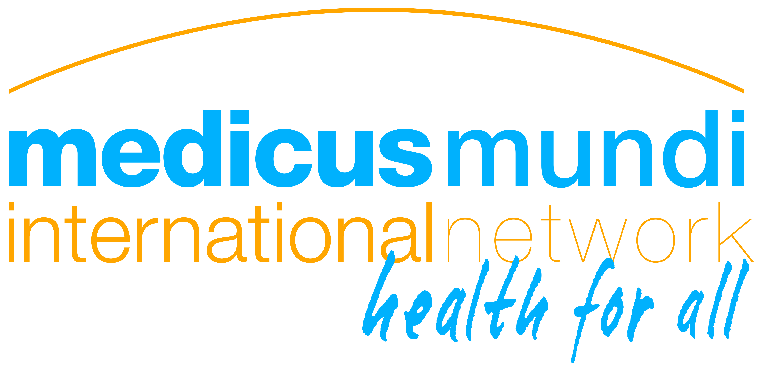
Draft for members consultation
MMI Board, 16 September 2020

MMI Network Strategy 2021-2025
The MMI Network Strategy 2020-2025 explains how our Network shall pursue the shared vision of its members and carry out its operational mission during the five years ahead.
The current challenging times of Covid-19 have been an eye-opener for a better understanding of the urgency to bring international health and the work of its actors to a next level. But the pandemic has also shown us how difficult it is to confidently plan the long term. In this sense, when we have taken strategic decisions and made choices based on our assessments and a strategy dialogue among the Board and membership, let us remain open for new challenges, new dynamics, and new opportunities.
The MMI Network Strategy 2020-2025 has been developed and drafted by the MMI Board in a series of workshops from November 2019 to August 2020 and related interaction with Network members. This process was disturbed by the Covid-19 pandemic that made it more difficult for us to come together. At the same time, the pandemic proved as a reality check for our analysis and planning that started before the outbreak.
This strategy will serve as a reference framework for annual planning for a maximum of five years, or less if the Board needs to review the strategy due to major external or internal changes.
The MMI Network Strategy 2021-2025 at a glance
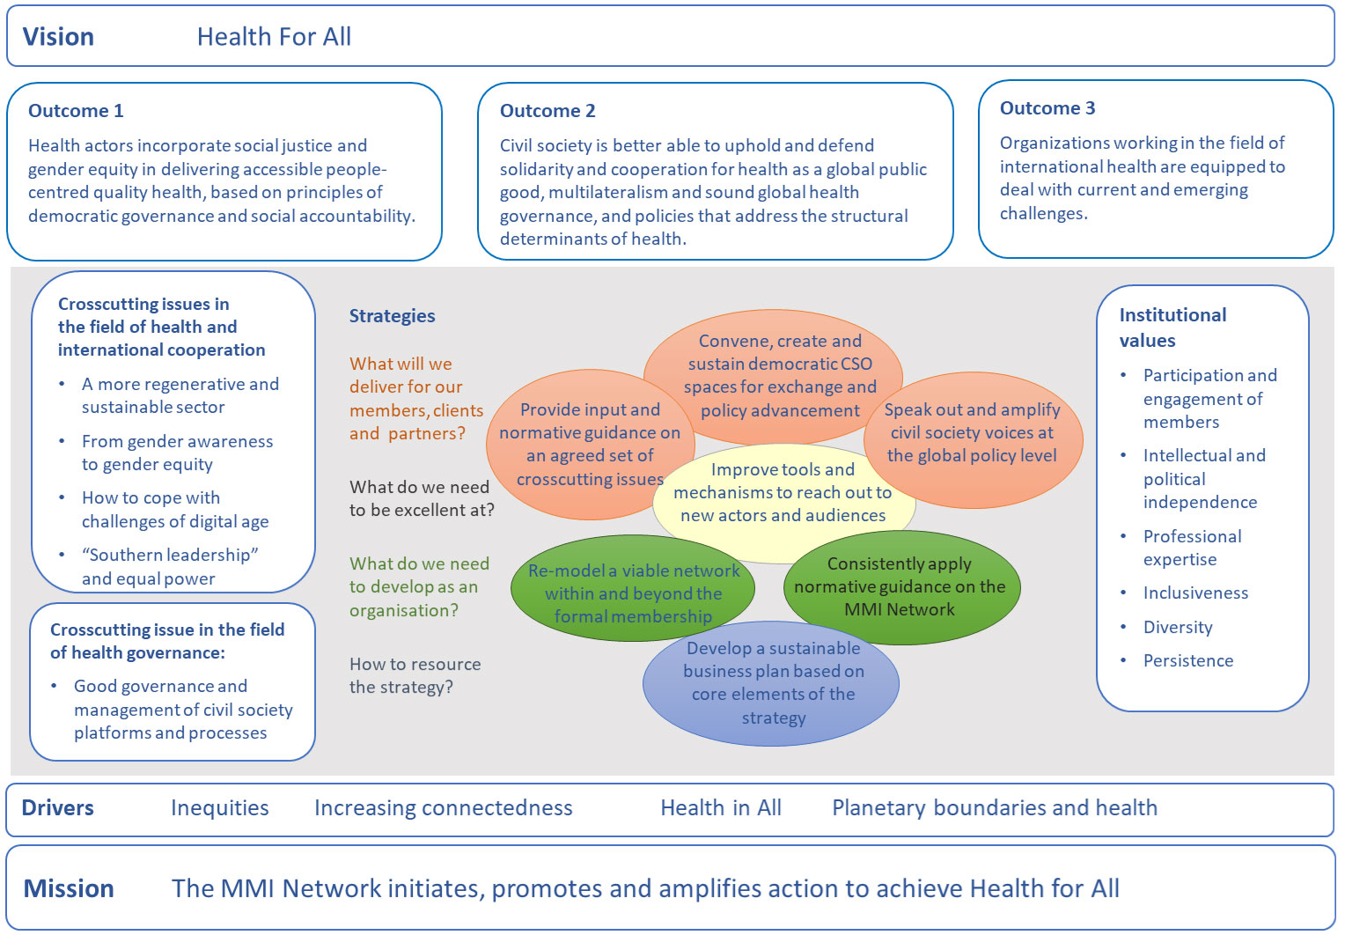

Draft for members consultation
MMI Board, 16 September 2020

MMI Network: Strategic objectives 2021-2025
This document introduces and outlines the seven interrelated strategic objectives at the core of the Network Strategy 2021-25. It will be complemented by a monitoring and evaluation tool and by an annual work plan. The documentation of the full strategy process including the drafting and definition of all strategy elements not explicitly outlined in this document can be ordered at the Network secretariat.

A. What will we deliver for our members, clients and partners?
1. Create, convene, and sustain relevant CSO spaces for exchange and policy advancement

The MMI Network and its secretariat have developed a sound reputation as a dedicated networker and convener for civil society engaged in international health. In addition to convening own workshops and thematic meetings, we have taken a leading role in setting up some civil society platforms that reach out far beyond the Network’s formal membership, in particular:
- Global health policy: Geneva Global Health Hub (hosted by MMI)
- Health cooperation and solidarity “beyond aid”: Kampala Initiative (co-hosted by MMI)
- Health workforce: Health Workers for All Coalition (currently hosted by MMI member Wemos).
These civil society spaces and communities are to be sustained and further developed; with MMI maintaining its strong engagement and leadership role and aligning its own advocacy in the fields covered by them.
A particular challenge that we will take up in the next years is to bridge between having such spaces for interaction and cooperation within civil society on one hand, and using them in an agile manner for reaching out to the relevant policy makers at a national and international level (see also objective 3).

2. Provide input and normative guidance on a set of important cross-cutting issues of international health cooperation

With our track record of promoting knowledge sharing, mutual learning and critical self-reflection among actors in international health cooperation and global health (Kampala Initiative, CSO governance), MMI is well positioned to continue and extend this role.
We have started the process of strategic reflection by considering some particularly urgent societal and political challenges as “drivers” for the development of the Network over the next years.
Moving from the analysis of our environment to fully taking them up in a sense of own commitment and action beyond our comfort zone, the MMI Network will, in the next years, consistently integrate and implement these drivers in the thematic work (objective 2) and the institutional setup (objective 6) of the Network.
Cross-cutting issues in the field of health and international cooperation
- How to make the health sector and international health cooperation regenerative and sustainable (planetary boundaries, carbon footprint).
- How to improve gender equity, addressing related issues of power and exploitation in the health sector and in international health cooperation.
- How to deal with challenges of a digitalization in the health sector and in international cooperation.
- “Southern leadership”: From lip service to equal opportunities and equal power
Cross-cutting issue in the field of health governance
- Good governance and management of civil society platforms and processes
To address these cross-cutting issues, we will set up thematic working groups or communities of reflection/practice hosted by the Network, convened by Network members ready to take the lead, supported by the secretariat, and open for a broad range of interested institutions and experts/practitioners. The process of sharing, learning and debating shall result in concrete, solid input and guidance (e.g. guidelines or position papers) for those engaged and for all actors working in the field of international health.

3. Speak out and amplify civil society voices at the global policy level

The MMI Network is well positioned to drive civil society advocacy on Health for All and Health in All. MMI is well connected with a variety of members and partners working at a local/national and international level, and engaged in service delivery, in advocacy for the right to health and for democratic global health governance, and in health policy and systems research.
Over the past years, the MMI Network has successfully engaged in debates on global health policy and governance and has become a valuable, respected and well known voice of civil society, in particular at the WHO, and in cooperation with other civil society actors.
The Covid-19 pandemic has reconfirmed the need (and opportunity) to link the global policy level with challenges and realities at national and grassroots realities, in order to promote change at both levels. MMI has actively contributed to doing so.
This allows the Network to further tap into global health policy processes, in strategic partnerships with members and other civil society organizations, social movements and networks, and amplifying civil society voices, based on evidence from the diverse contexts and realities represented in the Network to advocate for and to contribute towards inclusive, just, gender-sensitive and sustainable health policies and democratic global health governance.

What do we need to be excellent at?
4. Improve tools and mechanisms to reach out to new actors and audiences

The MMI Network relies on reaching out and bringing together an ever-growing constituency of civil society organizations and individuals (activists, practitioners, experts) who share a common vision and values and principles on health and are interested to join strategic alliances and to engage in thematic communities in view of promoting change. These might be (or become) Network members, but also institutions and individuals beyond the formal membership.
To reach out to new actors and audiences in a compelling way, MMI must invest in the set of tools and mechanisms to do so. This includes both tools for communication and interaction needed to reach the audiences where they are (objective 4), but it goes further: We will re-model the Network in a way that keeps a core of members in the lead but provides entry points for all who like to engage (objective 5), and we need to consistently take up the societal and cultural change wo promote in the institutional setup and culture of the Network (objective 6).

What do we need to develop as an organisation?
5. Re-model a viable network with a wide constituency

In our strategy, we frame the MMI Network mostly as a convener/host of civil society platforms (objective 1) and as a capacity centre that steers and manages a set of thematic communities (objective 2). This work will continue to rely on a small professional Network secretariat and an inner circle of members that are ready to sustain the Network, carry it forward and take the lead in particular endeavours. However, to make a difference (clout, relevance), we will need to reach out to a new and wider constituency.
To do so, we will re-model the Network in various ways:
- De-link engagement from formal membership, providing entry points for all who share our values and objectives, who commit to engage and are able to meaningfully contribute.
- De-link membership from financial support: Organizations who are committed to fully engage in the Network in a sense of becoming formal members shall be welcomed to do so. To achieve this, a new formula for membership and membership fees will be developed and implemented, including an amendment of the MMI statutes.
- Provide Network leaders with value for money. The Network will continue to rely on a set of core members who contribute some core funding to sustain the secretariat and activities. In an interaction with these members, MMI will come to a new agreement and formula of how they can benefit themselves of this investment, e.g. in terms of visibility/reputation, input into their work, or more concrete deliverables (see objective 7).
- Decentralize capacities. The strategy implementation depends on Network members who take the lead and provide the needed capacities. We will in particular explore the establishment of MMI thematic working groups fully and explicitly hosted by a Network member, and its consequences for the central capacities and budget of the Network (see objective 7).
As the current Executive Secretary will reach the age of retirement, we will also deal with the institutional continuity, in a dialogue with Medicus Mundi Switzerland who hosts the secretariat.

6. Consistently apply agreed analysis and instruments on the MMI Network

It is a matter of credibility and consistency to not only advocate for others “to do better” and invite them to engage in processes of institutional self-reflection and change, but to do the same as the convener of these processes.
In this sense, the list of cross-cutting issues and thematic working groups outlined above will become the list of how the MMI Network itself is expected to change over the next years, with its leadership actively engaging in these communities and applying the resulting normative guidance.
- If we advocate for respecting planetary boundaries, we cannot at same time expect our Network members to annually meet in Geneva and to fly into our network events....
- If we promote gender equity and full representation of the global south and want to reach out to a next generation, let us also consider changing the face(s) and leadership of the Network.
Again this will lead us out of our comfort zone. And it will take some effort to get there. But it is the time now, and the task shall be ambitions: MMI is to become itself a role-model and benchmark in these fields.

How to resource the strategy?
7. Develop a sustainable business plan based on core elements of the strategy

As a civil society advocacy network owned and supported by a small core group of members, and despite the broad appreciation for our work among and beyond our membership, MMI faces financial challenges. These have been assessed over the last years, but the resulting immediate action in extending membership and finding external “donors” have not yet led to concrete results.
To address the challenge of financial sustainability, MMI will set up a business plan that is based on the core elements of the strategy outlined above. Elements will include:

- Membership and support: Define better the general Unique selling points of MMI (what would we lose when MMI ceases to exist) as well as the Unique buying points for donors and funding members (what does MMI bring to strengthen the donor and the member in its own core business? What is the concrete return on their investment in the Network?).
- Sustain and extend paid mandates: The Geneva Global Health Hub and the Kampala Initiative have the potential to generate some income and core capacities at the MMI Secretariat. It is also in our financial interest that these civil society platforms and our related mandates are sustained and consolidated.
- Generate income and funding through thematic work. The burning cross-cutting issues addressed in the strategy and the task of providing concrete deliverables (in particular: normative guidance) have both the potential to find the attention of funders. In the implementation of our thematic work and in the overall promotion of the Network, we will systematically include fundraising activities. This might include de-linking capacities and budgets from the overall/central MMI budget and attribute them to Network members (see above, objective 5).

